3 Observable Trends:

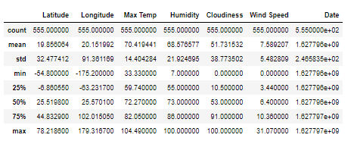

1. Majority of the locations have high humidity. The max temperature is 100% humidity. When we look at 75% of the data provided, which shows that the humidity is at 86%, which are higher than the average humidity overall.

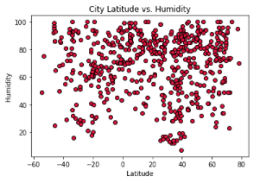

1. The percentage of cloudiness are about the same for all the cities. The average cloudiness is 51%. When looking at 25% of the data provided, cloudiness is at 10. When we look at 75% of the data, the cloudiness is at 91. This shows that the cloudiness is evenly distributed.

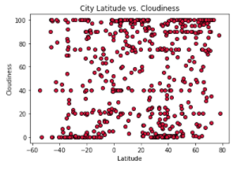

1. Majority of the cities have low windspeed. Out of 555 cities, the average wind speed is about 7mph. The max speed is also only 31mph. The below scatter plot also shows majority of the cities have low windspeed.

